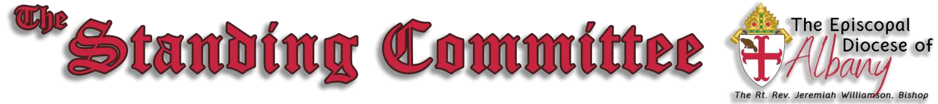

The
Very
Reverend
Tom Malionek
,

President

Janet Papa
,

Secretary

April 8, 2025
Among its canonically prescribed responsibilities, the Standing Committee serves as the Bishop’s Council of Advice. Our status and duties are set forth in Article IV of the Constitution of the Domestic and Foreign Missionary Society of the Episcopal Church, Canon 1.12 of the Canons of the Domestic and Foreign Missionary Society of the Episcopal Church, Article VII of the Constitution of the Diocese of Albany, and elsewhere throughout the Constitution and Canons of the Diocese.
The Constitution and Canons of the Episcopal Church may be accessed at https://generalconvention.org/constitution-and-canons/.
The Constitution of the Diocese of Albany may be accessed at https://albanyepiscopaldiocese.org/wpcontent/uploads/2021/12/Constitution-of-the-Episcopal-Diocese-of-Albany-Rev-2011.docx.pdf.
The Canons of the Episcopal Diocese of Albany can be accessed at https://albanyepiscopaldiocese.org/wpcontent/uploads/2023/01/The-Canons-of-the-Diocese-of-Albany-2022-version.pdf.
Visit https://albanyepiscopaldiocese.org/standing-committee/ for a list of Committee members.
These are highlights only. Some matters and details are sensitive, personal, or not ready to report. We do not comment on deliberations.
We welcome communication from around the diocese. Please view us as people of good will, and trust the Holy Spirit to guide us all.

Highlights
At its meeting on April 8, 2025, the Standing Committee took up, among others, the following matters:
- Advised the Bishop and consented to the Reinstatement of a priest to the Diocese of Albany.
- Adopted the minutes of the Standing Committee meeting of March 11, 2025.
- Consented to the Election of the Rev. Angel Roberto Rivera Rodriguez as Bishop of Cuba.
- Consented to the sale of property of Christ Church, Schenectady, subject to such conditions on the use of proceeds as may be recommended by the Trustees
- Welcomed the Bishop’s report on his recent House of Bishop meeting, activities and news about developments, including visitation of churches in the Diocese. He will be deconsecrating the space of Christ Church, Morristown on April 26th.
- Heard a report from the President of the Standing Committee regarding his retirement and waiting for the Holy Spirit to reveal the next plan for him. He shared observations about ways forward for parishes and the diocese.
- Received an updated report on the Convention plans for October.
May the Lord bless the people, congregations, and clergy of the Diocese of Albany.
Please continue to pray for us.

